**Mission Space Lab Phase 4 report outline**

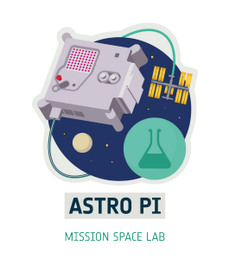

Team name:

Chosen theme: Life in Space/Life on Earth

Organisation name:

Country:

| Layout information:   * Your report must fit on no more than 4 pages of A4. Reports that exceed this length won’t be accepted. * Each section should have a title, as shown in this outline. * Please use the font ‘Verdana’ with the titles in font 14 and the main text in size 11. * All images and graphics should have a concise caption underneath the image. * Once your report is finished, save it as a PDF for submission. * Please avoid writing any personal data, such as student names or social media accounts in this report. |
| --- |

1. Introduction

In this section you should introduce your investigation. Explain what your team aimed to investigate, why this is interesting and what you expected to find.

This section is limited to 200 words.

2. Method

In this section you should explain what your team decided to measure, how you collected the data you needed and how you decided to analyse your data. You should explain any advantages or disadvantages of the methods that you chose.

Some things to think about are:

* What sensors did you use, and why?
* What type of data was collected? Images, text files etc.
* Was any of the data processed on Earth?
* If you used machine learning, did you use the Coral dongle to do this during your data collection, or during analysis when you had received your data?
* (Optional) If you are submitting a link to a GitHub repository with your report, briefly explain the additional programs/code you have written to help analyse your experiment data.

This section is limited to 200 words.

3. Experiment results

In this section you should present your results. We encourage teams to use pictures, charts and figures where they are helpful to explain your findings. This section is limited to 300 words.

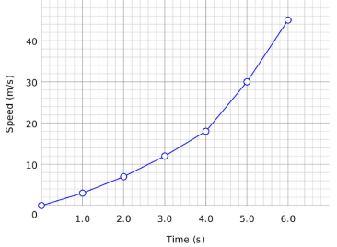

Figure 1 (example): Speed versus time

4. Learnings

This is a new section this year. Please tell us about your experience working as a team on Mission Space Lab. This shouldn’t just be limited to skills such as coding, using the hardware and analysis techniques (although we would love to hear about this too!). For example:

* How did you plan and organise your work as a team?
* What challenges did you experience and how did you overcome them?
* What did you learn?
* What would you do differently next time?

This section is limited to 200 words.

5. Conclusion

Don’t leave writing this section until the last minute — it is the most important! This is the final section that judges will read and should bring everything from your previous sections together. It is an opportunity for the team to share their reflections on their experience, their experiment design and results, and conclude on their findings. Did you find out what you were expecting? If not, why not? If your experiment did not produce any valid results, explain what you think went wrong and what you would do differently next time. This is still a valid finding.

This section is limited to 200 words.